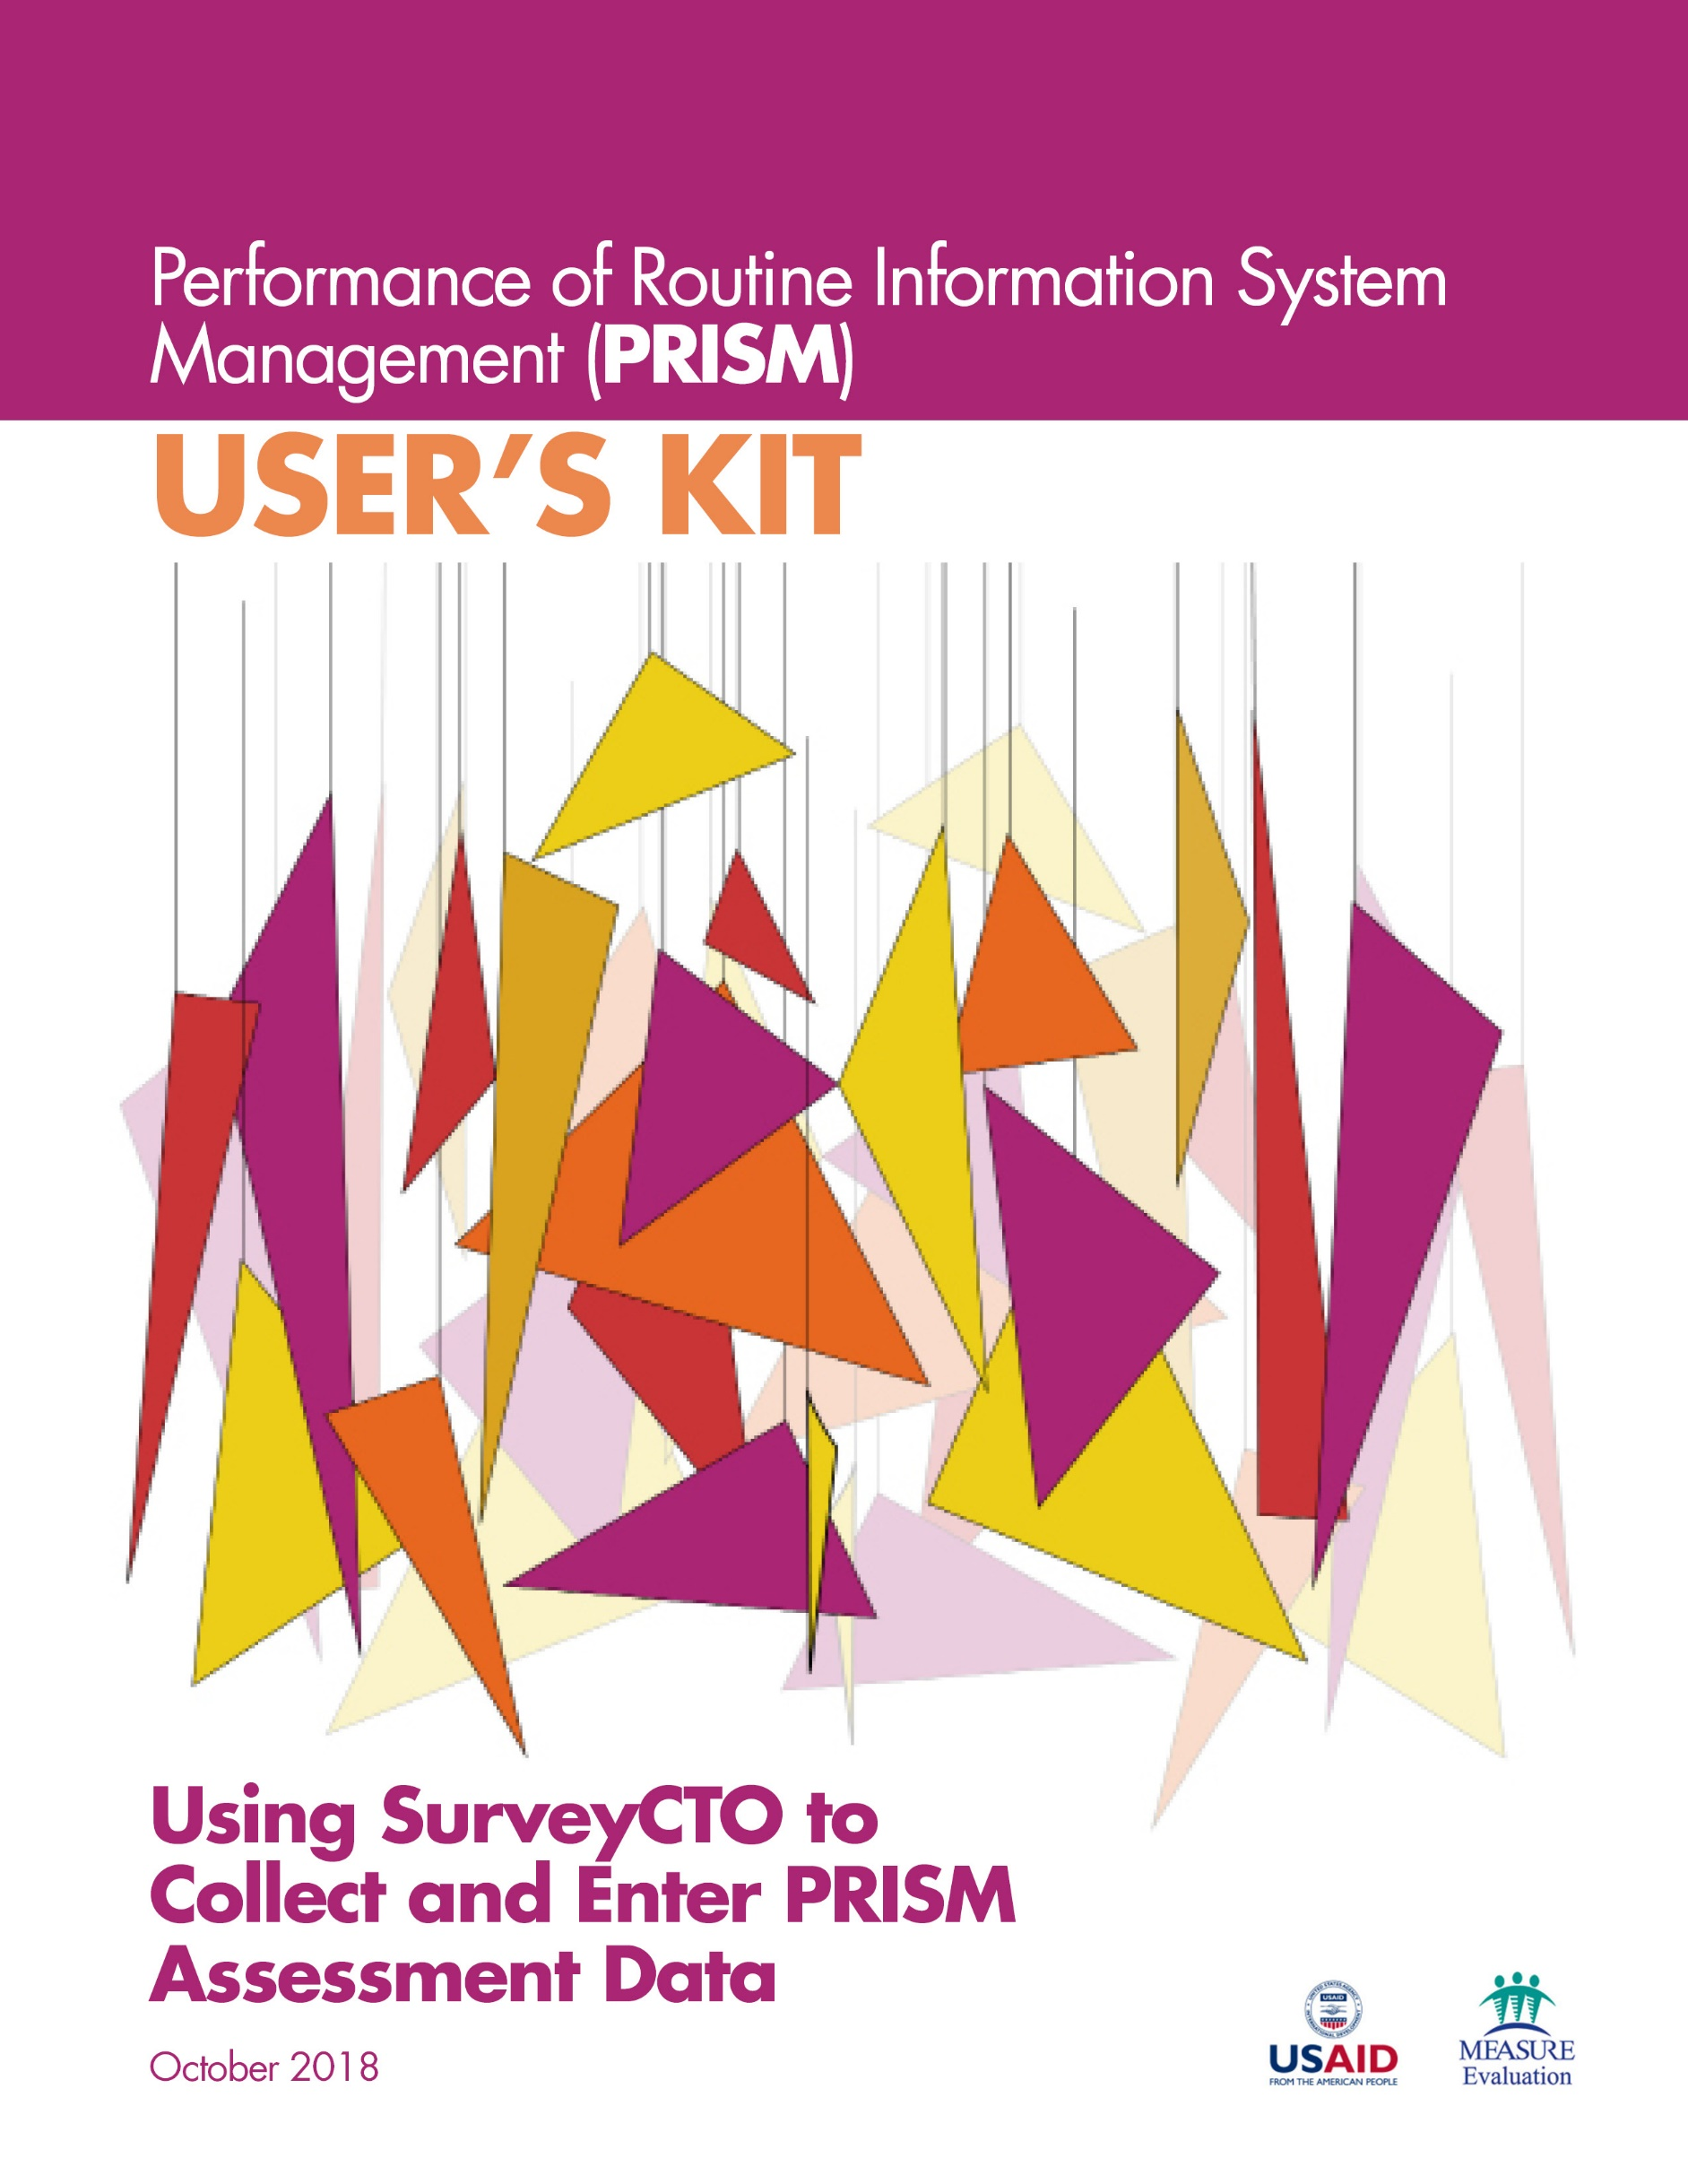

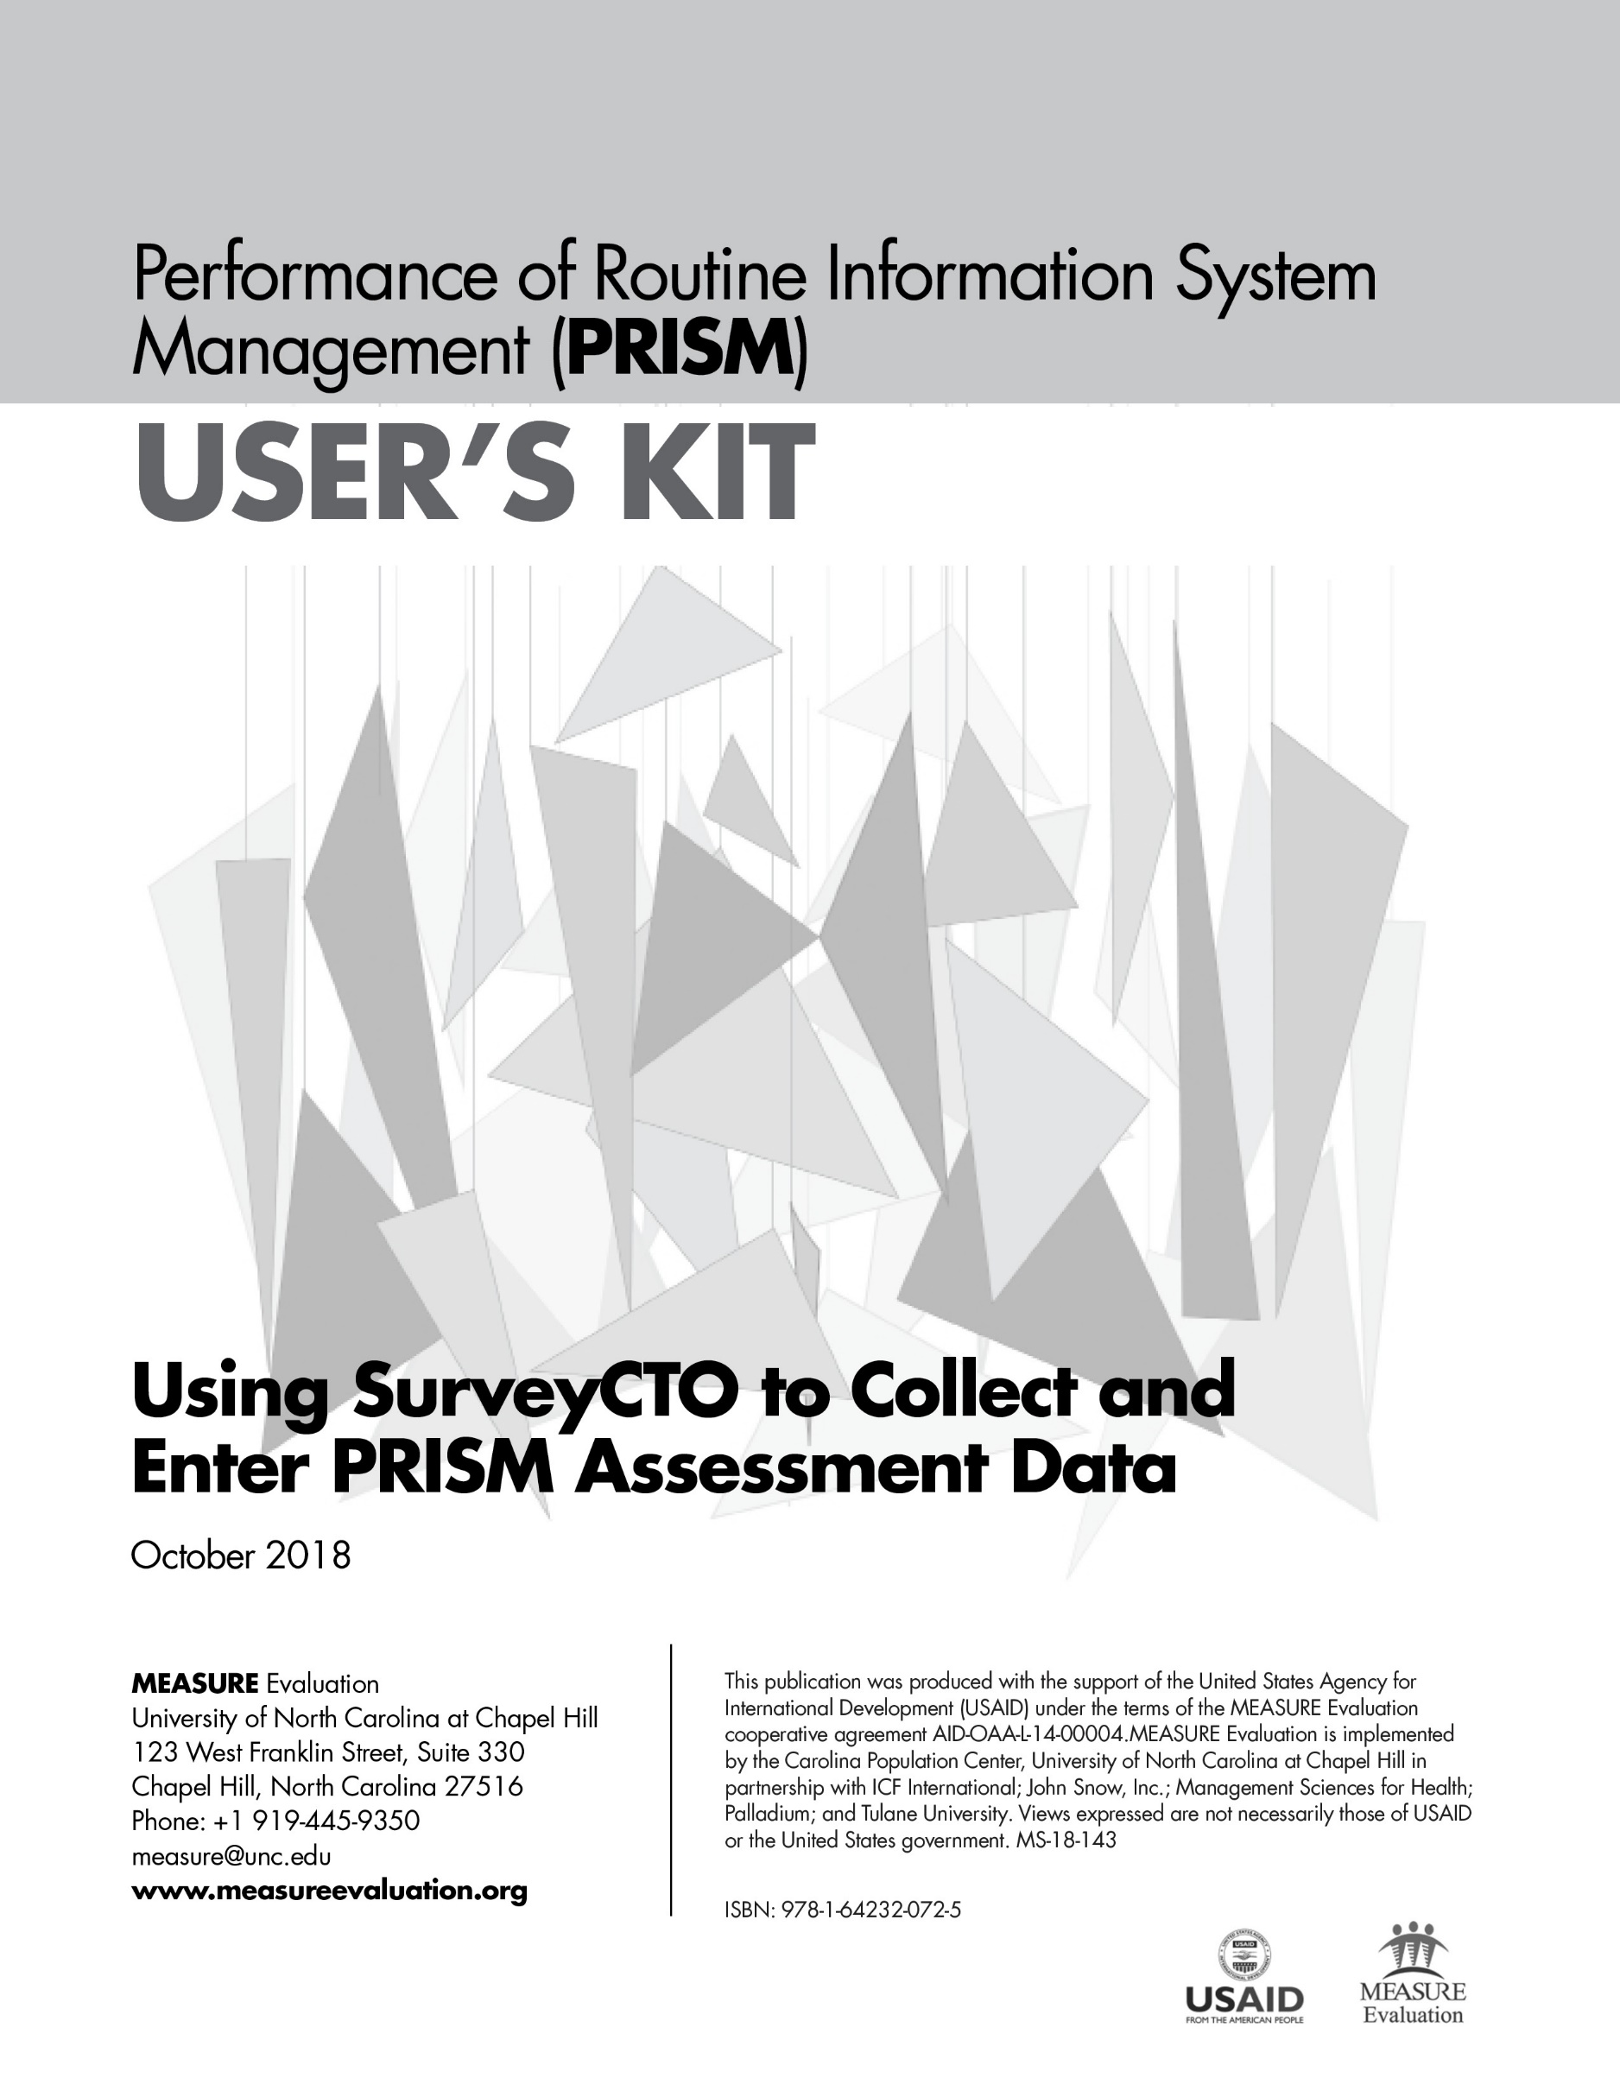

ACKNOWLEDGMENTS
MEASURE Evaluation, funded by the United States Agency for International Development (USAID), thanks those who contributed to the updated version of the Performance of Routine Information System Management (PRISM) Series – a collection of tools and supporting materials. It builds on the 2011 version of PRISM, developed by Anwer Aqil, Dairiku Hozumi, and Theo Lippeveld, all then members of MEASURE Evaluation, John Snow, Inc. (JSI), in collaboration with Mounkaila Abdou, JSI, and Alan Johnston, Constella Futures (now Palladium). This updated version draws on best practices and lessons learned from the many countries that have implemented PRISM assessments, as well as the new routine health information system (RHIS) Rapid Assessment Tool, developed by MEASURE Evaluation (available here: https://www.
measureevaluation.org/resources/tools/rhis-rat/routine-health-information-system-rapid-assessment-tool).
First, we wish to acknowledge USAID for its support.
Second, we thank the 80-plus respondents who answered our call for feedback on the original tools. We received feedback from GEMNet-Health partners as well as RHIS professionals from Afghanistan, Bangladesh, Canada, Ethiopia, Ghana, India, Indonesia, Kenya, Lesotho, Liberia, Malawi, Mexico, Namibia, Nepal, Nigeria, Philippines, Senegal, South Africa, Thailand, Uganda, the United States, and Zimbabwe.
Third, we extend our appreciation to the PRISM technical working group (TWG), an internal project advisory group, for its work in updating the tools. Members of the PRISM TWG are Tariq Azim, Alimou Barry, Hiwot Belay, David Boone, Suzanne Cloutier, Marc Cunningham, Mike Edwards, Upama Khatri, Sergio Lins, Moussa Ly, Amanda Makulec, Imelda Moise, and Kolawole Oyediran, from MEASURE Evaluation, JSI; Tara Nutley, from MEASURE Evaluation, Palladium; Sam Wambugu, from MEASURE Evaluation, ICF; David Hotchkiss, from MEASURE Evaluation, Tulane University; Stephen Sapirie, from MEASURE Evaluation, Management Sciences for Health (MSH); and Hemali Kulatilaka, from MEASURE Evaluation, University of North Carolina at Chapel Hill (UNC).
Fourth, we recognize the core team at MEASURE Evaluation for leading the revision effort and for their contributions. Special thanks go to Hiwot Belay, Sergio Lins, Suzanne Cloutier, Tariq Azim, and Jeanne Chauffour of MEASURE Evaluation, JSI, for their extensive work in revising and finalizing the PRISM Series.
Finally, we thank MEASURE Evaluation’s knowledge management team for editorial, design, and production services.

For any questions about the tools or implementing any part of the assessment, please contact:
measure@measureevaluation.org.

Suggested citation:
MEASURE Evaluation. (2018). Performance of Routine Information System Management (PRISM) User's Kit: Using SurveyCTO to Collect and Enter PRISM Assessment Data. Chapel Hill, NC, USA: MEASURE Evaluation, University of North Carolina.

CONTENTS
Abbreviations 7
Overview of the PRISM Series 8
Introduction to SurveyCTO 11
Subscribing to SurveyCTO 12
Uploading Forms Into SurveyCTO 13
Customizing the PRISM Tools 15
General Adaptation Topics 15
Adding Questions 15
Deleting Questions and Groups 16
Rephrasing Questions 16
Editing Form Definitions 16
Updating Responses 17
Checking Skip Instructions 18
Customizing Site Identification Data 18
Understanding Site IDs 20
Adaptation Notes for SurveyCTO Forms 21
Calculating Duration of Data Entry 21
Creating Interim Data Elements 21
Displaying Multiple Questions 21
Understanding “Other” Response Choices 21
Naming and Formatting Fields 22
Setting Up Repeated Groups 22
Recording Changes 22
Testing Forms 23
Previewing Forms 23
Deploying Forms 24
Testing Devices 24
Entering Data 24
Managing Data Collection Processes 24
Providing Access to Collaborators 25
Entering Data from Paper Surveys 25
Cleaning Data 25
Exporting Data for Analysis 26
Using SurveyCTO’s Data Explorer 26
Exporting to Stata 26
Exporting to CSV Files 26

ABBREVIATIONS

MAT Management Assessment Tool
MOH ministry of health
OBAT Organizational and Behavioral Assessment Tool
ODK Open Data Kit
PRISM Performance of Routine Information System Management
RHIS routine health information system
USAID United States Agency for International Development

OVERVIEW OF THE PRISM SERIES
Using data to make evidence-informed decisions is still weak in most low- and middle-income countries. Especially neglected are data produced by routine health information systems (RHIS). RHIS comprise data collected at public, private, and community-level health facilities and institutions. These data, gleaned from individual health records, records of services delivered, and records of health resources, give a granular, site-level picture of health status, health services, and health resources. Most are gathered by healthcare providers as they go about their work, by supervisors, and through routine health facility surveys.
When routine data are lacking, or are not used, the results can be lower-quality services, weak infection prevention and control responses, lack of skilled health workers available where they are needed, and weak supply chains for drugs and equipment. These factors contribute to poor health outcomes for people.
MEASURE Evaluation, which is funded by the United States Agency for International Development (USAID), has provided technical and financial assistance to strengthen RHIS for more than 15 years. We have contributed to best practices at the global level and to the strengthening of RHIS data collection, data quality, analysis, and use at the country level. One of the project’s mandates is to strengthen the collection, analysis, and use of these data for the delivery of high-quality health services.
MEASURE Evaluation developed the Performance of Routine Information System Management (PRISM) Framework and suite of tools in 2011 for global use in assessing the reliability and timeliness of an RHIS, in making evidence-based decisions, and in identifying gaps in an RHIS so they can be addressed and the system can be improved. The framework acknowledges the broader context in which RHIS operate. It also emphasizes the strengthening of RHIS performance through a system-based approach that sustains improvements in data quality and use. PRISM broadens the analysis of RHIS performance to cover three categories of determinants that affect performance:
- Behavioral determinants: The knowledge, skills, attitudes, values, and motivation of the people who collect, analyze, and use health data
- Technical determinants: The RHIS design, data collection forms, processes, systems, and methods
- Organizational determinants: Information culture, structure, resources, roles, and responsibilities of key contributors at each level of the health system
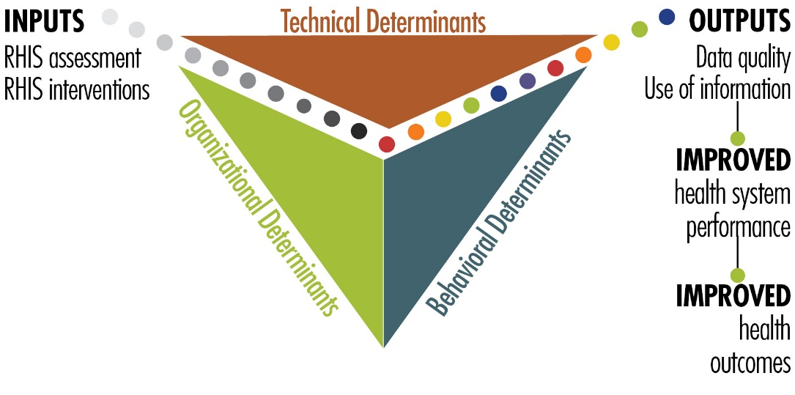
Figure 1. PRISM Framework

What the 2018 PRISM Series Offers
With USAID’s support, MEASURE Evaluation has revised the PRISM Tools and developed other elements, based on the PRISM Framework, to create a broad array of materials: the “PRISM Series.” It’s available on the MEASURE Evaluation website (https://www.measureevaluation.org/prism) and has the following components:
- PRISM Toolkit
- PRISM Tools (this is the fundamental manual of the PRISM Toolkit)
- PRISM Tools to Strengthen Community Health Information Systems
- Analysis Tool for Data from a PRISM Assessment
- PRISM User’s Kit (consisting of four guidance documents)
- Preparing and Conducting a PRISM Assessment
- Using SurveyCTO to Collect and Enter PRISM Assessment Data (this document)
- Analyzing Data from a PRISM Assessment
- Moving from Assessment to Action
- PRISM Training Kit
- Participant’s Manual
- Facilitator’s Manual
- 9 PowerPoint training modules
This new, more comprehensive PRISM Series is useful for designing, strengthening, and evaluating RHIS performance and developing a plan to put the results of a PRISM assessment into action.
The revised “PRISM Tools”—the PRISM Series’ core document—offers the following data collection instruments:
RHIS Overview Tool
This tool examines technical determinants, such as the structure and design of existing information systems in the health sector, information flows, and interaction of different information systems. It looks at the extent of RHIS fragmentation and redundancy and helps to initiate discussion of data integration and use.
Performance Diagnostic Tool
This tool determines the overall level of RHIS performance: the level of data quality and use of information. This tool also captures technical and organizational determinants, such as indicator definitions and reporting guidelines, the level of complexity of data collection tools and reporting forms, and the existence of data-quality assurance mechanisms, RHIS data use mechanisms, and supervision and feedback mechanisms.
Electronic RHIS Performance Assessment Tool
This tool examines the functionality and user-friendliness of the technology employed for generating, processing, analyzing, and using routine health data.
Management Assessment Tool
The Management Assessment Tool (MAT) is designed to take rapid stock of RHIS management practices and to support the development of action plans for better management.
Facility/Office Checklist
This checklist assesses the availability and status of resources needed for RHIS implementation at supervisory levels.
Organizational and Behavioral Assessment Tool
The Organizational and Behavioral Assessment Tool (OBAT) questionnaire identifies behavioral and organizational determinants, such as motivation, RHIS self-efficacy, task competence, problem-solving skills, and the organizational environment promoting a culture of information.

Uses of the PRISM Tools
These PRISM tools can be used together to gain an in-depth understanding of overall RHIS performance, to establish a baseline, and to rigorously evaluate the progress and effectiveness of RHIS strengthening interventions every five years, contributing to the national RHIS strategic planning process. Each PRISM tool can also be used separately for in-depth analysis of specific RHIS performance areas and issues.

INTRODUCTION TO SURVEYCTO

The data entry function for PRISM has been developed in Version 2.41 of SurveyCTO (2018), hereafter referred to as SurveyCTO. SurveyCTO is a software platform based on Open Data Kit (ODK) with enhanced functionality for designing forms, collecting data, monitoring data quality, analyzing data, and more. Its security features include transport encryption, device-side and server-side data redundancy, support for easy survey data encryption with a user-defined public/private key pair, and the option for unencrypted data to be restricted to cold room computers (computers totally disconnected from the Internet and all other networks).

SurveyCTO hosts its subscribers on fixed, stable Linux servers that are maintained by internal personnel. Every subscription is built and maintained on a separate virtual server that includes the SurveyCTO server software, as well as matching versions of the Android and desktop software components.

Data are exported by SurveyCTO in .csv format, which can be imported to any visualization or analysis software you choose, including the PRISM Analysis Tool – available at this link: www.measureevaluation.org/prism. SurveyCTO can also write out Stata do-files that will import, reshape, and label your data. There are several other options for integrating with various popular platforms (e.g., Google Sheets and Microsoft Excel). More information is available at this link: https://www.surveycto.com/product/integrations. Note that the availability of some features is dependent on the type of subscription you have.

To distinguish between the hard copy PRISM Tools and the SurveyCTO PRISM tools, this guide will refer to the hard copy tools as paper tools and to the SurveyCTO tools as forms. This is consistent with the terminology used by SurveyCTO, which refers to survey instruments as forms.

SUBSCRIBING TO SURVEYCTO

To use the electronic forms developed in SurveyCTO, you will need a subscription. Subscription information can be found at this link: https://www.surveycto.com/plans/. On this web page, you will have the option of obtaining a fee-based subscription or, by scrolling down to the bottom, a free (but more limited) community subscription at this link: https://www.surveycto.com/community-contract/.

The community subscription is sufficient for conducting a PRISM assessment if you do not add modules to the SurveyCTO PRISM forms or submit more than 200 forms in a month. If you exceed the limits, you can upgrade to a paid subscription (team-based pricing), which has higher limits for forms, submissions, and data storage than the community subscription does. Note that with the free community subscription, you will be required to engage with the SurveyCTO community monthly. SurveyCTO will prompt you each month to engage in one of several different ways (e.g., writing a post, sending a picture, or helping someone in the SurveyCTO Support Center).

All SurveyCTO subscriptions start with a free 15-day, no-commitment, no-credit-card-required trial, which, according to the website, “includes all of SurveyCTO’s features – including 24/7 access to professional support – but is limited to one team, 10 forms, 200 form submissions, and 200MB of data storage”. The free trial has the same features as the community subscription. At the end of the trial period, you will need to pick between a paid subscription and the free community subscription.

To start, fill out the form for the free 15-day trial and select a server name and password at this link: https://login.surveycto.com/signup/index.html. Note that you will not be able to change the server name later, so choose the name wisely. After you have submitted the completed form, a verification email will be sent to the email address you specified. Click on the link in the verification email and SurveyCTO will create your virtual server. When it is ready, you will receive a confirmation email with the link to your server. That will be the URL that you will use to access your server going forward. It will be in the format https://[your server name].surveycto.com; for example, “https://prism.surveycto.com”.

UPLOADING FORMS INTO SURVEYCTO

Once your server has been created, you may upload into SurveyCTO the electronic files, called form definitions, that are available for download on the MEASURE Evaluation website at this link: www.measureevalution.org/prism. Table 1 lists the form definitions by module. Note that there is a Module 2a for the district level and a Module 2b for the health facility level. Module 3 has two components: “Part 1. Functionality” and “Part 2. Usability”. Thus, there are eight forms representing the six modules of the paper PRISM Tools (see Table 1).

Table 1. SurveyCTO form definitions, by module in the PRISM Tools
Module | Title | SurveyCTO Form Definition
1 | RHIS Overview Tool | mod1_rhis_ovrvw_v1.xlsx
2a | RHIS Performance Diagnostic Tool–District Level | mod2a_rhis_perf_diag_v1.xlsx
2b | RHIS Performance Diagnostic Tool–Health Facility Level | mod2b_rhis_perf_diag_v1.xlsx
3 | Electronic RHIS Functionality and Usability Assessment Tool–Part 1. Functionality | mod3_erhis_assmnt-p1_v1.xlsx
 | Electronic RHIS Functionality and Usability Assessment Tool–Part 2. Usability | mod3_erhis_assmnt-p2_v1.xlsx
4 | Management Assessment Tool (MAT) | mod4_mat_v1.xlsx
5 | Facility/Office Checklist | mod5_facil-offc_chklst_v1.xlsx
6 | Organizational and Behavioral Assessment Tool (OBAT) | mod6_obat_v1.xlsx

Log in to your server website (i.e., https://[your server name].surveycto.com). You will be taken to the 1.Design tab on your server console. The top section, How to design your survey forms, is a short tutorial on how to design forms. The section below it—Your forms and datasets—allows you to add forms and see existing forms. Follow the steps below to add the first form definition to SurveyCTO:
- Click on Add your first form... and you will see three buttons displayed: Start new form, Add sample to explore, and Upload form definition.
- Click on Upload form definition. Below the button, the Upload form definition section will be displayed.
- Click on Upload from computer if your form definitions are saved on your computer or another storage device (e.g., a USB drive). If you saved the form definitions on Google Drive, click Upload from Google Drive.
- Under Please choose a form file to upload (.xls, .xlsx, or .xml):, click on + Select file… This will open a window to allow you to locate where you stored your form definitions. Note that only one file at a time can be uploaded. Select the desired file for upload.
- At the bottom of the screen, under Form upload options, there are two choices: Deploy immediately or Upload as draft only. The first choice deploys your form, which allows you to collect data using that version. The second choice creates a draft version of your form that can be used only for testing (i.e., data cannot be collected using a draft version). Select the desired option.
- Click on the Upload button. An information box will be displayed informing you of the status of the upload. If it is successful, your form is in SurveyCTO.

Recommendation: Upload your form definitions as draft only and then deploy them once they have been tested thoroughly and are ready to use for data collection.

After you have uploaded your first form, information about it will be displayed in the Your forms and datasets section. To add more forms, click the + button (above or below your form) and follow steps 2–6 described above. Once you have added all your forms, you can reorder them by dragging and dropping them in whatever order you desire.

CUSTOMIZING THE PRISM TOOLS

The PRISM Tools (both the paper tools and SurveyCTO forms) on the MEASURE Evaluation website are standardized, with the intention that there will be minimal adaptation to your country’s context. In this section, broad issues related to adaptation will be covered first, followed by the customization process for site identification, and, finally, notes about the structure of the SurveyCTO forms.
It is expected that there will be few changes to the PRISM Tools apart from the site identification data; working with those data is detailed under the Customizing Site Identification Data subsection below. Nonetheless, if there is a need to change the questions, responses, or skip instructions in the PRISM Tools, advice on how to proceed and where to be careful are discussed in the General Adaptation Topics subsection. The next section, Adaptation Notes for SurveyCTO Forms, focuses on the structure of the SurveyCTO form definitions.

In some cases, the customization process will be the same for the paper tools and the electronic forms, so we will not make a distinction between them. In other cases, the revisions will be addressed from the perspective of the paper tools and the electronic forms, because updates may be handled differently by SurveyCTO than a change made on paper (e.g., skip instructions).

Recommendation: Revise the paper tools first. Once your changes are final, revise the electronic forms. Although it may seem counterintuitive, this will make the adaptation process more efficient and ensure that the electronic forms match your newly-adapted paper tools.

General Adaptation Topics
The customization process may include any of the following actions:
- Add, change, or delete questions
- Add, change, or delete responses
- Add, change, or delete skip instructions

Adding Questions

When adding questions, a concern is what to do about the field names/question numbers. Suppose you want to add a couple of questions to a section. Depending on the questions’ location in the PRISM module, the addition could require extensive renumbering if you wanted to keep the questions sequential. Renumbering will most likely affect skip patterns and the calculation of indicators. Rather than renumbering questions, use a unique numbering system to identify added questions (e.g., after DQ_033 you might add DQ_033x1, DQ_033x2, and so on). That will maintain the sequential nature of the questions without disrupting the structure of the module. You must still be mindful of the skip instructions and incorporate your additional questions in those instructions, if appropriate. Make sure that any new questions have a unique identifier, because SurveyCTO may not work as expected with duplicate field names. Note that new questions will not be incorporated automatically into the calculation of indicators.

Recommendation: When adding questions, use a unique numbering system to identify added questions. Be aware of skip instructions and update as necessary.

Deleting Questions and Groups

In general, deleting questions is more straightforward than adding questions, with respect to question numbers. Gaps in the numbering system do not create a problem, unless you delete a question with an attached skip instruction or one that is used in an indicator calculation. If you delete a question with a skip instruction, the questions that would have been skipped will appear unconditionally. Respondents will be forced to give an answer even if the question is not applicable. That is not a desirable situation and should be avoided. Deleting questions that are part of an indicator could cause errors in the PRISM Analysis Tool.

In SurveyCTO, groups are used to organize fields. A group may be an internal construct set up to manage when questions should appear, or it might be used to visibly organize questions into sections. Groups are also used to repeat certain questions that need to be asked more than once (e.g., questions S1_01 to S1_03 in the RHIS Overview Tool are repeated for every paper-based data recording tool). Be careful when deleting groups in a form definition. There may be a skip instruction – contained in the validation column of the SurveyCTO form definition – on the begin group row that would need to be copied to all the data elements that were contained within the group.

Recommendation: When deleting questions, it is not necessary to renumber the remaining questions. Be sure not to delete key data elements used in calculating indicators or fields/groups with attached skip instructions.

Rephrasing Questions

Aside from adding and deleting, you may need to modify the wording of questions. This is easy, as long as the wording change does not alter the intent of the question. If that is the case, revise the wording to reflect your country’s context. If what is being measured by the question changes and the question is used in an indicator calculation, it will affect the validity of the indicator. In that scenario, leave the original question intact and add a new question to measure the new concept.

Editing Form Definitions

Once you have customized the paper tools to reflect your country’s needs, you must change the electronic forms to match. There are two ways to edit form definitions: (a) on SurveyCTO, using the Form Designer, or (b) on an external spreadsheet, such as Microsoft Excel or Google Sheets. To use the Form Designer, click on the Edit icon in the same row as the name of your form in the Your forms and datasets section. It will display all fields and groups in your form.

Note that it is not the intention of this user guide to replicate the instructions on how to manage forms in SurveyCTO, because the online documentation is clear and will provide the necessary guidance. Detailed help is available on the Design tab in the upper right corner next to your login ID. Click on the Documentation icon and you will be taken to the main Help page. A good place to start is by reading the documentation under Designing forms–Core concepts in the left-most column menu. An overview with links to all the online documentation is available at this link: https://support.surveycto.com/hc/en-us/articles/218263767-Getting-the-most-out-of-your-SurveyCTO-documentation.

If you want to edit a form in Microsoft Excel or Google Sheets, open the form definition in the desired program and familiarize yourself with the format. There are three worksheets/tabs that contain the information that SurveyCTO needs to create and administer a form: survey, choices, and settings. Note that these worksheets will only be visible on Microsoft Excel or Google Sheets when downloaded from SurveyCTO in that format (as do all future references to sheets or worksheets).

The survey sheet specifies details about the data collected by your form (i.e., about the fields or questions in your form). The choices sheet lists all the labels and stored values (e.g., “Yes” has a stored value of “1”) for categorical questions. The settings sheet has columns for the form title, form ID, and other formwide settings. Most, if not all, of the revisions done as part of the customization process will affect the survey and choices sheets (i.e., questions and responses, respectively).

Recommendation: Start by editing your form definitions using SurveyCTO’s Form Designer. The formatting will be done automatically for you and saved correctly. Once you are comfortable with the format and syntax, you can use Microsoft Excel or Google Sheets to edit your forms, if desired.

Updating Responses

The next topic related to revising the PRISM Tools focuses on responses to questions. In the Form Designer, a list of responses is editable in place, whenever you edit a categorical question that uses it. In the form definition worksheet, the responses to questions are listed in the choices sheet. The first column, list_name, specifies the name that identifies a distinct set of responses; the second column, value, specifies the stored value for a given response; and the third column, label, specifies the description for each response. The fourth and fifth columns, image and filter, are not used by the generic SurveyCTO forms, but could be employed during customization. The filter column can be used to filter a list of responses shown to users based on prior selections (e.g., facility names based on district name). For more information, visit this link: https://[your server name].surveycto.com/help.html#Help_Designing-forms_advanced-topics_cascading-selects.

If it is necessary to update the responses to a question, you first need to determine which list_name identifies those responses. This can be found on the survey sheet in the form definition worksheet. The list_name associated with a question appears in the first column of the row that corresponds to the question (see Table 2a). The list_name can then be located in the choices sheet (see Table 2b).

Table 2a. Extract of a single-response question (survey sheet)
type | name | label | . . . . .
select_one facil_typ | RHIS104 | RHIS_104. Type of facility

Table 2b. Responses for type of facility (choices sheet)
list_name | value | label | image | filter
facil_typ | 1 | National referral hospital
facil_typ | 2 | District/provincial hospital
facil_typ | 3 | Health center
facil_typ | 4 | Health clinic
facil_typ | 5 | Health post
facil_typ | 6 | District health office
facil_typ | 7 | Regional/provincial health office
facil_typ | 8 | Central ministry of health (MOH)

Questions are identified by the name and label columns, respectively (i.e., field name and description). As shown above, the type of question is specified in the type column. Categorical questions are identified as either single choice or multiple choices, followed by the list_name. Single choice questions (i.e., only one response is allowed) are specified as select_one, while multiple-choice questions (i.e., check-all-that-apply) are specified as select_multiple. Along with select-one and select_multiple, other common non-categorical question types found in SurveyCTO forms are text, integer, date, note, and calculate.

There are considerations when updating responses. For changes to the value or label, it is important to check if a response option is used in a relevance or constraint column in the survey sheet. If so, it may be necessary to modify the code (also referred to as a statement) in those columns to maintain the flow of the questionnaire. Otherwise, questions that are not applicable may be asked mistakenly or questions that should be asked may be skipped. Note that a list_name can be used by more than one question, so locate all places where it appears, to ensure it still works for the other questions.

Checking Skip Instructions

The last general topic related to revising the PRISM Tools concerns skip instructions. On paper, skip instructions indicate which question to go to next, depending on the response to the current question. On the one hand, questions that are not applicable are skipped as you move forward in the paper tool. On the other hand, SurveyCTO uses a field called relevance to indicate when questions (or groups of questions) should appear. This is based on responses to earlier questions, to ensure that only appropriate future questions are displayed. When skip instructions are changed on paper, be sure to convert them accurately to relevance statements in SurveyCTO; otherwise, your data may not be collected properly. Information on relevance statements can be found at this link: https://[your server name].surveycto.com/help.html#Help_Designing-forms_core-concepts_relevance.

Customizing Site Identification Data
At the beginning of every module, you will find one or more sections that collect key data for uniquely identifying sites where a PRISM assessment is conducted. It is essential for the site identification data to be collected in the same way across modules, to enable linking the modules by site. Site identification sections are represented as groups in the form definitions. Rows can be added in those sections, to reflect the number of health system administrative levels in the country. The labels can be changed to match the country’s administrative level names. Once the administrative levels have been updated, renumber all the questions that share the same prefix and numbering scheme as specified in Table 3, columns 3 and 4. This is the only exception to the recommendation not to renumber questions.

Table 3. Site identification fields, by module
PRISM Module | Admin Level/ Facility Type | Site Identification based on Admin Level/Facility Type | Related Fields
RHIS Overview Tool | RHIS104 | UNIT IDENTIFICATION  (RHIS105h – RHIS110h) | RHIS112 – RHIS113
FACILITY IDENTIFICATION
(RHIS105f – RHIS111f)
RHIS Performance Diagnostic Tool–District Level | n/a | DISTRICT LEVEL UNIT IDENTIFICATION  (DQ104 – DQ108) | DQ109 – DQ111
RHIS Performance Diagnostic Tool–Health Facility Level | FQ109 | FACILITY IDENTIFICATION  (FQ104 – FQ111) | FQ112 – FQ114
Electronic RHIS Functionality and Usability Assessment Tool–Part 1. Functionality | ESF104 | UNIT IDENTIFICATION  (ESF105 – ESF107) | ESF108 – ESF111
Electronic RHIS Functionality and Usability Assessment Tool–Part 2. Usability | ESU104 | UNIT IDENTIFICATION  (ESU105h – ESU110h) | ESU112 – ESU116
FACILITY IDENTIFICATION
(ESU105f – ESU111f)
Management Assessment Tool (MAT) | MAT104 | UNIT IDENTIFICATION  (MAT105 – MAT109) | MAT110 –  MAT111
Facility/Office Checklist | FOC104 | UNIT IDENTIFICATION  (FOC105h – FOC110h) | FOC112 – FOC114
FACILITY IDENTIFICATION
(FOC105f – FOC111f)
Organizational and Behavioral Assessment Tool (OBAT) | OBAT104 | UNIT IDENTIFICATION  (OBAT105h – OBAT110h) | OBAT112 – OBAT113
FACILITY IDENTIFICATION
(OBAT105f – OBAT111f)

N.B. The above field names represent the names used in SurveyCTO forms (the questions, as they appear in the paper tools, have underscores: e.g., RHIS_104).

Understanding Site IDs

As noted earlier, the SurveyCTO forms have been designed for easy linkage. A hidden field (one that is internal only—i.e., not part of the user interface) has been created to uniquely identify a site. Called siteid, it is calculated immediately following the site identification sections and consists of the concatenation of each administrative level in order from highest to lowest, including the facility. Below are examples of siteids from the RHIS Overview Tool, where RHIS104 is the facility type, the administrative level IDs are two-digit numeric values, and the facility ID is a five-digit numeric value. Note that the concatenation of values to create the siteid is done in SurveyCTO via the calculate row.
- For central MOH or a regional/provincial health office (RHIS104 > 6)
if RHIS105h=12
siteid =12-00-00000
- For a district health office (RHIS104 = 6)
if RHIS105h=12 and RHIS106h=34
siteid =12-34-00000
- For any health facility, from health posts to hospitals (RHIS104 < 6)
if RHIS105f=12 and RHIS106f=34 and RHIS107f=56789
siteid =12-34-56789

If there is a different number of administrative levels than the three levels represented in the generic PRISM Tools, the siteid must be modified, to incorporate all levels correctly. This will require the following steps:
- Add or delete rows to represent the number of health system administrative levels in the appropriate section of all of the modules—both the paper tools and the electronic forms (see Table 3). Change the description to reflect the name used by the health system for each administrative level.
- Renumber the appropriate fields so that they are sequential (see Table 3). Ensure that the rows are in order, from the highest to the lowest administrative level, which is usually the facility.
- Change the facil_typ response list if necessary and update the relevance statements to match the administrative levels with the facility types.
- Update the calculate statements in the survey sheet that are associated with the siteid. Ensure that the concatenation formulas include all the administrative levels. These must be synchronized across the forms, to maintain the link by site.

Even if it is not necessary to modify the administrative levels, it may be necessary to update the facility types. In that case, Step 3 above is all that needs to be done.

ADAPTATION NOTES FOR SURVEYCTO FORMS

In the section above, customization was presented from the viewpoint of what was being revised. The focus of this subsection is on the design and organization of the SurveyCTO forms. There is no inherent order to the topics covered, because they are not necessarily related but instead are tips that will enhance your understanding of how SurveyCTO was implemented for PRISM.

Calculating Duration of Data Entry

As aforementioned, SurveyCTO has some internal fields—hidden from the user interface—that are part of every form. Three fields are of particular interest: startime, endtime, and duration. SurveyCTO captures the start and end times of data entry for a form and uses them to calculate the duration of data entry in seconds. A calculated field called duration_min was added to every form, to convert duration to minutes. It is not a key field used in indicator calculations, but may be useful in monitoring data collection.

Creating Interim Data Elements

Sometimes it is necessary to create interim/temporary data elements during the creation of a new field; for example, siteid required interim data elements in some forms. Interim data elements are calculated fields that are needed during data collection, but are unnecessary once data collection is done. They are exported with the other data and can be deleted if you do not want them to clutter your analysis file.

Displaying Multiple Questions

In general, the SurveyCTO forms are designed to display one question per screen, but there are some exceptions. Groups are used to designate sections that appear in the paper tools and consist of all the questions included in a section. Subgroups are used to apply relevance statements (i.e., skip instructions) to multiple questions, so that they do not have to be repeated for each question. As noted previously, be mindful of the skips when updating questions or responses. Other subgroups are used to display more than one question on a screen: for example, matrix type questions and questions with the same wording. These groups have “field-list” in the appearance column.

Understanding “Other” Response Choices

Questions that include a response such as “Other (specify)” will consist of two related data elements. The first will be the categorical question that included “Other (specify)” as a response. The second will be a text field that allows the “specify” part of the response to be entered. The text field will have a relevance statement that refers to the first question. For example, RHIS111f (Managing authority) has as one of its responses “Other (specify)” with a value of 96. The next question, RHIS111fo, is a text field that is “relevant” only when RHIS111f=96. Note that these two questions cannot be displayed on the same screen.

Naming and Formatting Fields

Below are the naming/formatting standards used in the SurveyCTO forms:
- User-entered fields are in capital letters. Fields that are not entered by a user are lower case (e.g., notes, groups, and internal/hidden fields such as calculated fields).
- In general, all user-entered fields are required, unless blank/null is a valid value.
- In some of the tools, the survey fields have the following suffixes:
  - f = valid for facility level only, e.g., FOC105f
  - h = valid for district and higher levels only, e.g., FOC105h
  - blank = valid for all levels, e.g., FOC012
- Groups have a prefix of “grp_”.
- Notes have a prefix of “note_”.
- Labels for matrix-type questions have a prefix of “label_”.
- Interim/temporary data elements are calculated fields and have a prefix of “tmp_”.
- Text fields that represent the “specify” part of “Other (specify)” responses have a lower case “o” appended to the originating field name (e.g., RHIS111fo).
- The choices sheet is sorted in ascending order by list_name; the values are in the same order as they appear in the paper tool.
- If a form includes calculated data elements other than duration_min and siteid, a sheet called calculated data elements will appear as a new tab before the survey sheet. It will contain the following information: (a) calculated data element name, (b) description, (c) purpose/use, and (d) how it is calculated (i.e., the fields on which it is based).

Setting Up Repeated Groups

In the RHIS Overview Tool form definition, repeated groups were used for the tabular questions: for example, “Section 1. Paper-based Data Recording Tools”. Because there is no predefined limit on the number of columns, no limit was set on the number of subgroups within the repeated groups. Each column of data in the table will result in one subgroup, which will contain the questions (e.g., S1_01, S1_02, and S1_03).

Recording Changes

It may be helpful to keep a record of the changes made to the forms, so you know what was changed and when it was changed. This is particularly important if a form does not work as intended and you need to troubleshoot the cause. A revision history can be created easily as a Word document. Another option is to insert a sheet (i.e., a new tab) in the form definition to document the changes to the form. SurveyCTO will ignore additional sheets in the form files when uploaded. For example, a sheet labeled “Revisions” could be inserted in front of the survey sheet with the following fields: date, sheet (survey, choices, settings), field/group/list name, and description.

Recommendation: Create a simple history of revisions to help troubleshoot a form that does not work properly and as documentation of the customization process.

Testing Forms
When you are finished with your revisions, you can upload your form into SurveyCTO as described previously or save it in Form Designer. If there is an error in the form, you will receive an error message and not be able to upload/save it until it is fixed. Note that there may be warning messages for minor syntax issues and so forth that will not stop you from uploading/saving your form but could pose a problem during data collection. Research all warnings and fix if appropriate. Information on debugging forms can be found at this link: https://[your server name].surveycto.com/help.html#Help_Designing-forms_performance-and-debugging.

Previewing Forms

SurveyCTO has a preview function that allows forms to be tested without saving the data. There are two ways to preview a form: (a) inside the Form Designer via the Edit function, or (b) outside the Form Designer in the Your forms and datasets section where your forms are displayed. Either way, click on the Preview icon and it will take you to the beginning of your form. While you are testing within Preview, everything internally works as if it is actually collecting data. All calculations, logic, skip instructions, and so forth will work as they would during data collection. If you want to view the data that you have entered, click on the Go to prompt in the upper right corner of the title bar. Fields that are visible to the user and their associated responses will be displayed using the following color codes:
- Red: unanswered, required
- Blue: unanswered, not required
- Green: answered

Note the possibility that not all of the fields will be displayed at any given time. This is because of relevance statements that control which questions are presented. For example, if there is a filter question that must be answered “Yes” for the next section to appear, the section will not be displayed unless you have answered “Yes” to the filter question. If there are no relevance statements in your form, all fields will be displayed.

When you start a form in Preview, the data that you enter will be stored and available for viewing until you either close the browser window/tab or reach the end of the survey and click on Submit. As soon as you take either of these actions, whatever you were working on is discarded.

Note that when you have a form that is either a draft version only or a deployed version only, it makes no difference which preview method you use. If, however, you have both a draft and a deployed version of a form in the Your forms and datasets section, use the Preview function within the Form Designer (after clicking on Edit) to test the draft version and the Preview function outside the Form Designer to test the deployed version.

Deploying Forms

When you have completed revising and testing your forms, you must deploy them if they are in draft mode. You can deploy a draft version by clicking on Deploy, next to the draft version number in the Your forms and datasets section. Version numbers for both deployed and draft forms are in the format: yymmddhhmm (e.g., 1810122038 if it is October 12th, 2018 at 8:38pm). Once your forms are deployed, you can start collecting data.

Testing Devices

If you are using mobile devices for data collection, be sure to test your forms on all devices planned for use in the field. This needs to be done to ensure the format is conducive to the device. For example, a small personal device, such as a phone, may have a display space that is too small to adequately display the module questions, causing issues in scrolling down or across to read and respond to the questions.
SurveyCTO allows forms to be printed from an html format if you would like a hard copy. For more information, visit this link: https://[your server name].surveycto.com/help.html#Help_Designing-forms_additional-topics_printable-copies.

Entering Data
The actions described in the previous subsection occurred within the 1.Design tab. Data collection starts on the 2.Collect tab on the server console.

There are two ways to enter data in SurveyCTO: (a) using the SurveyCTO Collect app on an Android phone or tablet, or (b) using a web browser. A tutorial about data entry is available in the Collecting data with SurveyCTO section on the 2.Collect tab. Information is also available in the online documentation under Collecting data at this link: https://[your server name].surveycto.com/help.html#Help_Getting-started_overview.

Managing Data Collection Processes

There are many factors to consider when deciding how best to implement the PRISM assessment using SurveyCTO. Because the online documentation is detailed and presents guidelines to assist in making decisions about how to manage the data collection process, it will not be repeated here. The links to a few noteworthy articles are below:
- Fieldwork device help topic setup guide
https://support.surveycto.com/hc/en-us/articles/115015924507-Fieldwork-device-help-topic-setup-guide
- What Android device should you buy?
https://support.surveycto.com/hc/en-us/articles/360000151988-What-Android-device-should-you-buy-
- What are incomplete submissions and how do I manage them?
https://support.surveycto.com/hc/en-us/articles/115015995648-What-are-incomplete-submissions-and-how-do-I-manage-them-

Providing Access to Collaborators

Regardless of which method you use to enter data in SurveyCTO, you must give access to all the users who will have a role in data collection. A description of the user roles is available at this link: https://[your server name].surveycto.com/help.html#Help_Getting-started_overview_managing-users. Users may be added, changed, or deleted in the Your users section at the bottom of the Configure tab on your server console. Note that it is not necessary to give every user a unique login ID, especially if they have the same user role (e.g., “Data collection only”). They can be assigned the same password to share during the assessment. This applies to other user roles, too.

Entering Data from Paper Surveys

While most of the PRISM modules are basically the same in the paper copy and electronic versions, there are a couple of exceptions. In the RHIS Overview Tool, “Section 4. Information Flow Sheet” does not lend itself well to the electronic survey platform, so it can only be filled out on paper. Likewise, the OBAT is a self-assessment questionnaire that is filled out on paper and then scored by a subject-matter expert. The scores can later be entered in SurveyCTO so that they will be available for analysis with data from the other modules.

Even though SurveyCTO is a very powerful platform for managing surveys, it is not necessary to go overboard in an attempt to use all of the interesting features. The PRISM Tools have been designed to allow for its simple, straightforward implementation in SurveyCTO. If your country’s infrastructure does not support mobile data collection, the PRISM modules can be administered on paper and then entered in SurveyCTO via a web browser.

Recommendation: Keep the implementation of the PRISM assessment simple – it should be based on your country’s needs and the resources available to support it. Not all features in SurveyCTO are required for a successful PRISM assessment.

Cleaning Data
Before analyzing the data, it is always good to verify the data that were entered in order to identify any data entry errors. You can save time in data cleaning by creating edits to signal mistakes during data entry. In SurveyCTO, this is done in the constraint column for integer responses (e.g., age cannot be a negative value). Many constraints were added to the generic SurveyCTO forms to avoid data entry errors during the PRISM assessment.
While data are being collected, there are optional mechanisms to monitor the data and implement automatic quality checks if desired. Outliers may be identified by creating data quality checks and flagging values that are not in line with previously entered data. These quality checks are available at the 3.Monitor tab on your server console. The online documentation explains these features in the Monitoring and management section at this link: https://[your server name].surveycto.com/help.html#Help_Monitoring-and-management.

Exporting Data for Analysis
Once the data are clean, there are many options for analysis. Below is a brief description of the various analysis options. Topics related to exporting and analyzing data may be viewed at this link: https://[your server name].surveycto.com/help.html#Help_Exporting-and-publishing-data_overview.

Using SurveyCTO’s Data Explorer

SurveyCTO has a built-in analysis tool that can be used both during and after data collection for monitoring and analysis, respectively. To explore your data directly using SurveyCTO's Data Explorer, follow the steps below:
- Click on the 4.Export tab on your server console.
- In the Your data section, click Explore form data next to the form of your choice.
- Click on the Start Data Explorer button. This will open the Data Explorer, which allows you to summarize data submitted for individual fields, summarize the relationships between two fields, and drill down to browse individual submissions.

Exporting to Stata

Although the Data Explorer provides some visualization and analysis capabilities, it is limited. If you would like to export your data to Stata, SurveyCTO can automatically generate Stata do-files. Starting at Step 3 above, in Data Explorer, proceed with the following steps:
- Click on Download. There will be four tabs displayed.
- Click on the Stata .do template tab.
- Under Format of your data exports:, select the Wide option.
- Click on Download. For most forms, SurveyCTO will output two files: import_FORMID.do and FORMTITLE_corrections.csv (where FORMID and FORMTITLE are replaced by the form's ID and title, respectively).

There also is a way to download the Stata do-files from the 1.Design tab on the server console. Click on Download next to the form of your choice and then click on Stata .do template. From there, follow Steps 6 and 7, above. As noted previously, the Stata do-files format your data but do not provide any analysis.

Exporting to CSV Files

Finally, data may be exported to .csv files that can be imported into a spreadsheet, database, statistical analysis software, or the PRISM Analysis Tool. To export your data, follow the steps below:
- Click on the 4.Export tab on your server console.
- In the Your data section, click Download form data next to the form of your choice.
- Under Export to:, select the Wide format.
- Click on Download data now. Your .csv file will be displayed in the Exported data section.
- Click on the file name to save it.

The .csv files may be uploaded into the PRISM Analysis Tool for analysis of key indicators. The PRISM User’s Kit: Analyzing Data from a PRISM Assessment describes this tool in detail and is available at this link: https://www.measureevaluation.org/prism.

Dobility, Inc. SurveyCTO [Technology for digital data collection]. (2018). Cambridge, MA, USA. Retrieved from http://www.surveycto.com .

